# EEE3088F 2023 Initial Design Template

# Q1 Github [1]

<https://github.com/BestNkhumeleni/EEE3088F_group22_2023>

# Q4 Microcontroller interfacing Failure Management [5]

### (i) component failure/destruction

We’ll have extra micro controllers to attach the hat to in the case of microcontroller failure.

### (ii) trace damage

In the even that the microcontroller trace is broken or damaged, we can use one of our other micro-controllers.

### (iii) component shortage

This is unlikely to happened as the micro-controllers are already in our possession, but if all ours break then well have a fourth spare that is not being used at that time to run the code into.

### (iv) errors in your circuit design that are only detected post manufacture.

We will have a second code base in case our primary code base breaks, or track different versions of our code using git hub and trace back when we run into code breaking issues.

We will also have extra microcontrollers in case our primary one breaks.

We can also reconfigure pins, if a pin breaks, we could set another pin to do its job instead.

### Q7 Microcontroller interfacing Schematic [10]

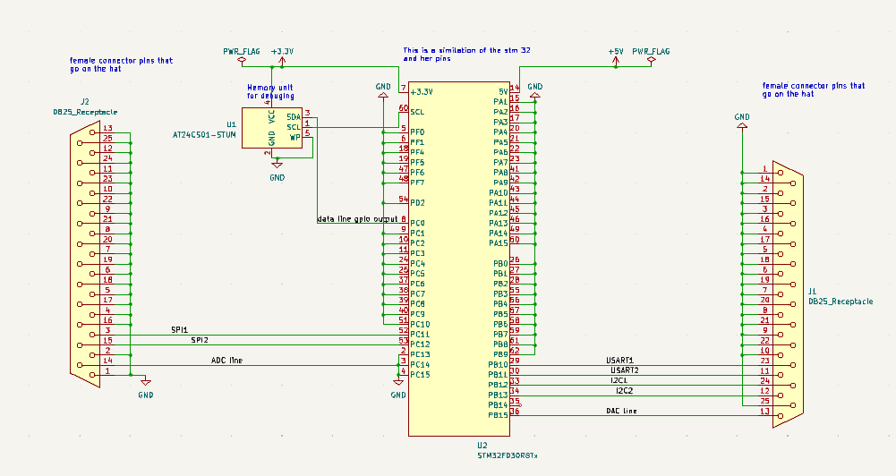

### Q8 Planned ERCs [5]

Reverse polarity testing

Voltage limiting

On/off scenarios

Overcurrent testing

### Q9 Updated BOM [4]

Updated bill of materials for the micro controller interfacing:

<https://github.com/BestNkhumeleni/EEE3088F_group22_2023/blob/main/BOM/Intergration/Book1.xlsx>